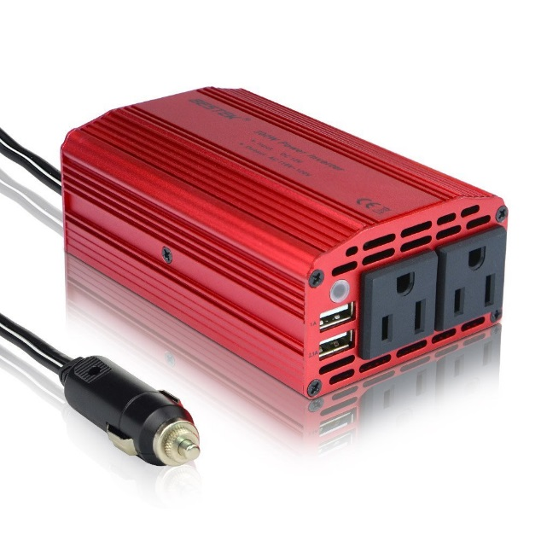

**BESTEK® Amazon's #1 Power Inverter Brand**

• Devoted to designing a portable with high performance power inverter gained the highest average review rating.   
• Providing best quality products of newly-fashionable and superior with professional customer service and end-users. 

**Product Specification :**

• Power (2 AC Outlets): 300W Rated, 350W Max, 700W Peak   
• Input Voltage: 12V DC, Output voltage: 110V~120V   
• Dual USB Port Output: DC 5V, 3.1A rated. One USB with 1A and the other with 2.1A   
• Indicator: Green-operation, Red-shutdown   
• Over Voltage Shutdown: DC 15V-16V, Low Voltage Shutdown: DC 10V-11V 

**Optimal Use and Precautions :**

• For DC12V and Car ONLY, not applied for DC 24V and airplane use.   
• The cooling fan remains on continuously. This means you'll only be able to use it in situations where the car is running.   
• Avoid placing the inverter into sunlight directly or next to heat-sensitive materials to protect Inverter from getting too warm.   
• Get to know its voltage using range, not allowed high power electric devices such as hair dryer, electric heaters, curling iron and etc. 

**Package List :**

• 1 x 300W Power Inverter   
• 1 x User Manual 

**Good to Know: with 12 Months Warranty and Provide Friendly, Easy-to-Reach Support.**